# **Appium Automation Test Cases**

# **Prepared By – Sonia Gulia**

**Task** – pick up a random Android Application and add Ui testing.

**Solution** – Added Automated test cases using Appium.

**Tools Used**

1. Appium Server – For executing test cases.
2. Eclipse – Used for writing the client side code in java
3. Android Studio – Configured android studio for creating the Android Virtual Devices.
4. Emulator – Testing the android app
5. Junit framework – Negative testing test
6. UIAutomationViewer – Finding the app elements

**Types of tests automated**

1. Text box entry
2. Scrolling through the list of items
3. Negative testing to capture toast messages.
4. Shopping Cart
5. Gestures
6. Long Pause
7. Navigating to chrome browser and back to the application.

Here are the screen shots of all the configured tool stacks

* Appium Server - Logs from Appium server showing the executed test cases.

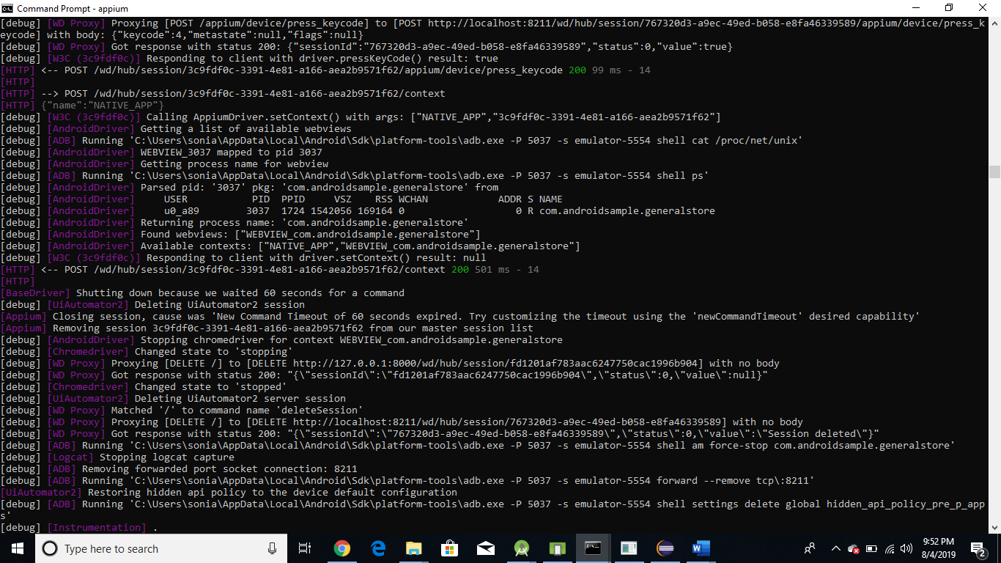

* Eclipse – Showing the actual java client code. I will also attach the java code classes.

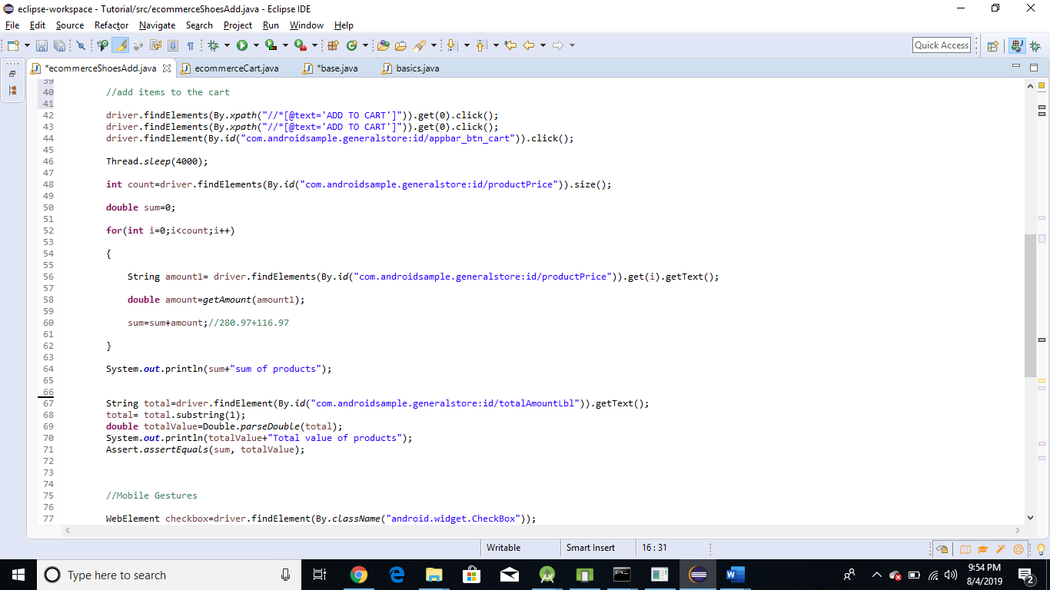

* Android Studio – Showing the configured virtual devices

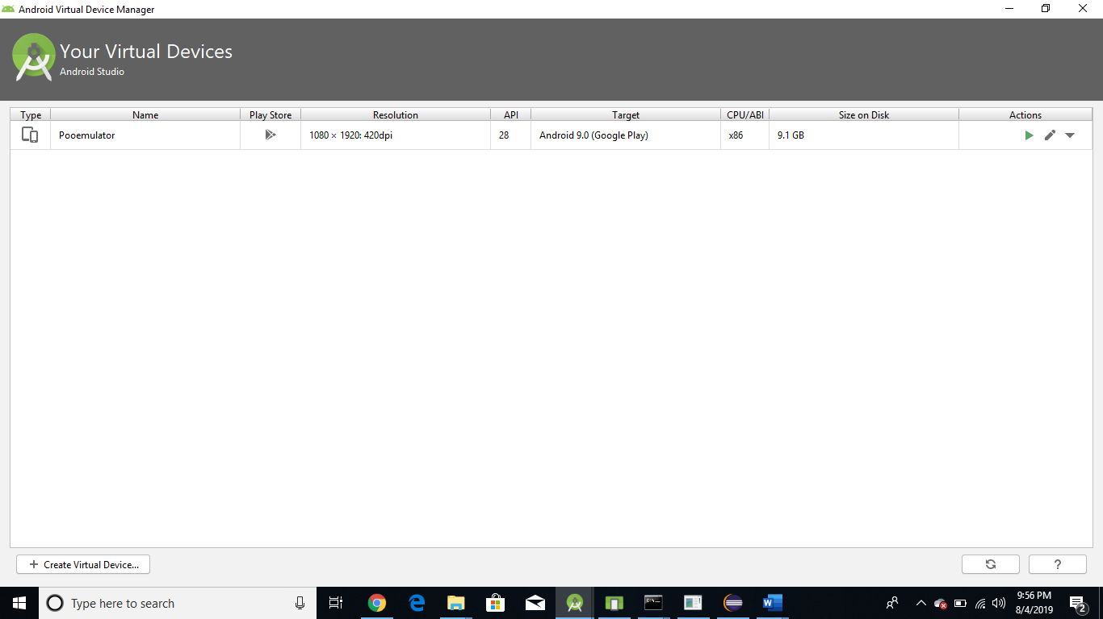

* Emulator – Testing the android app

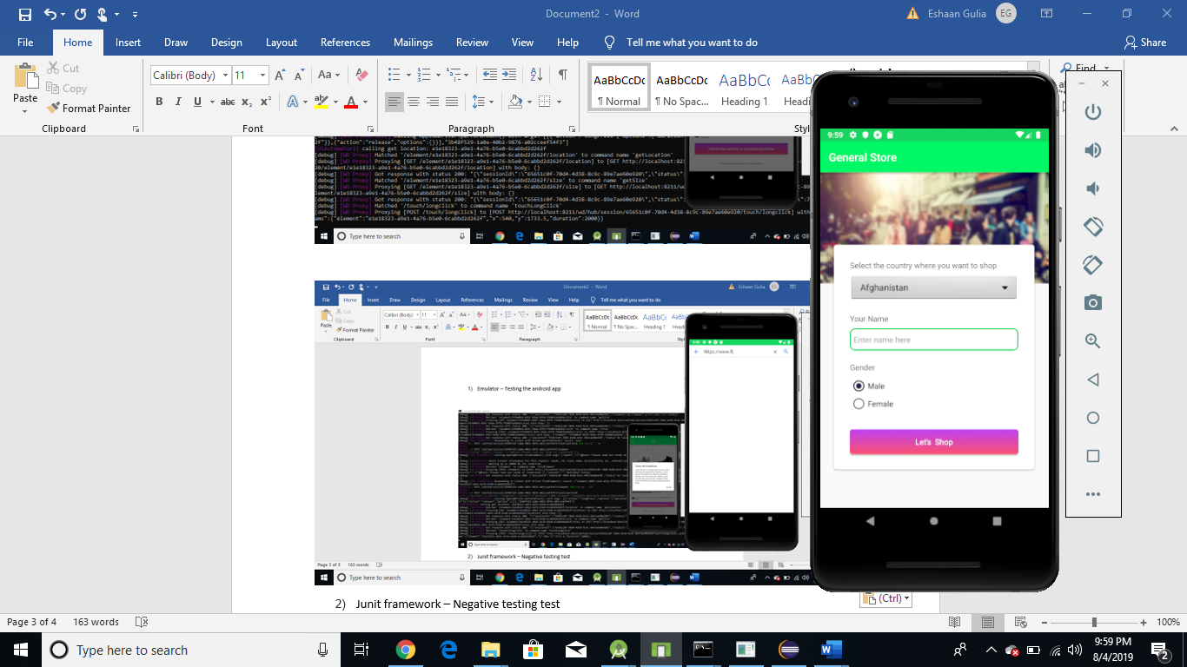

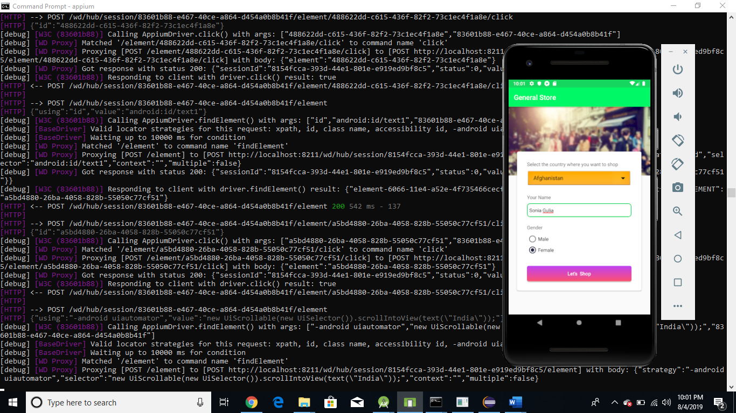

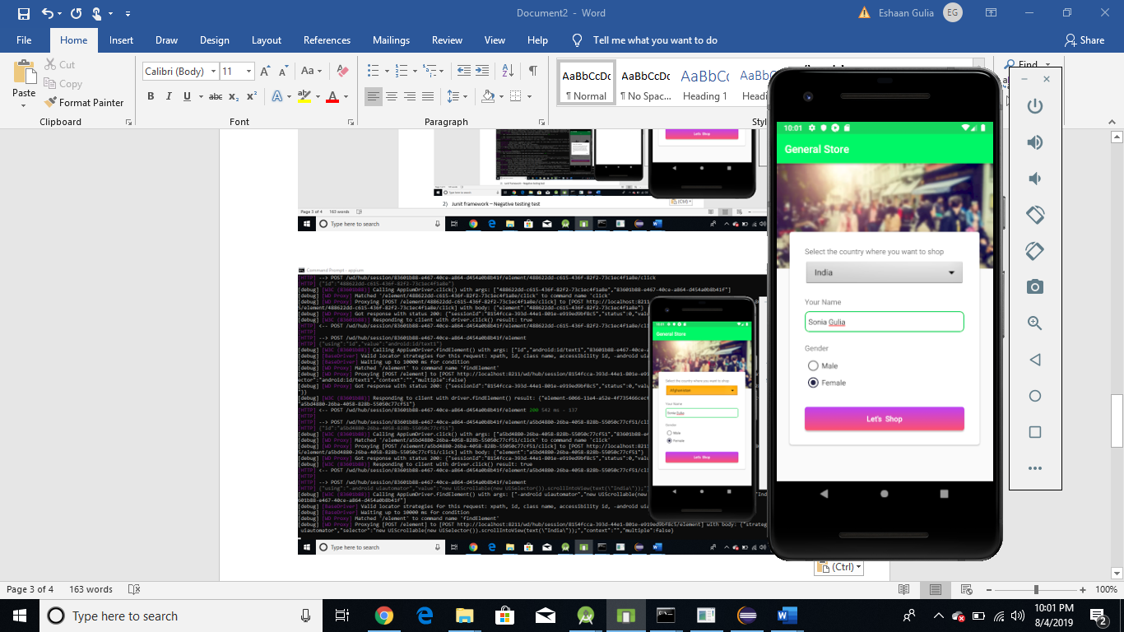

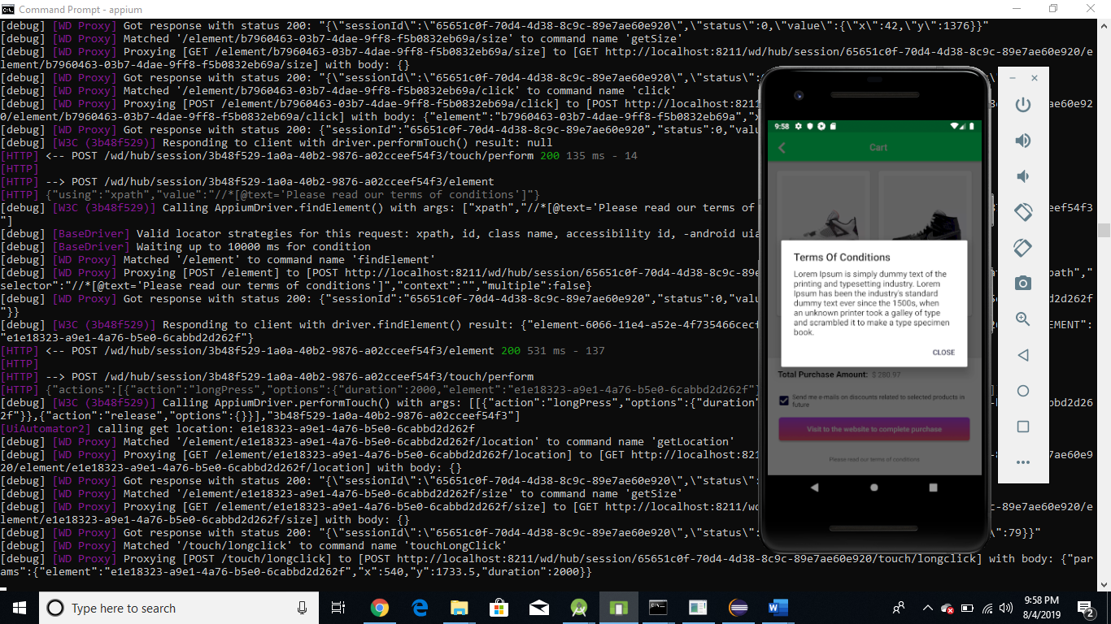

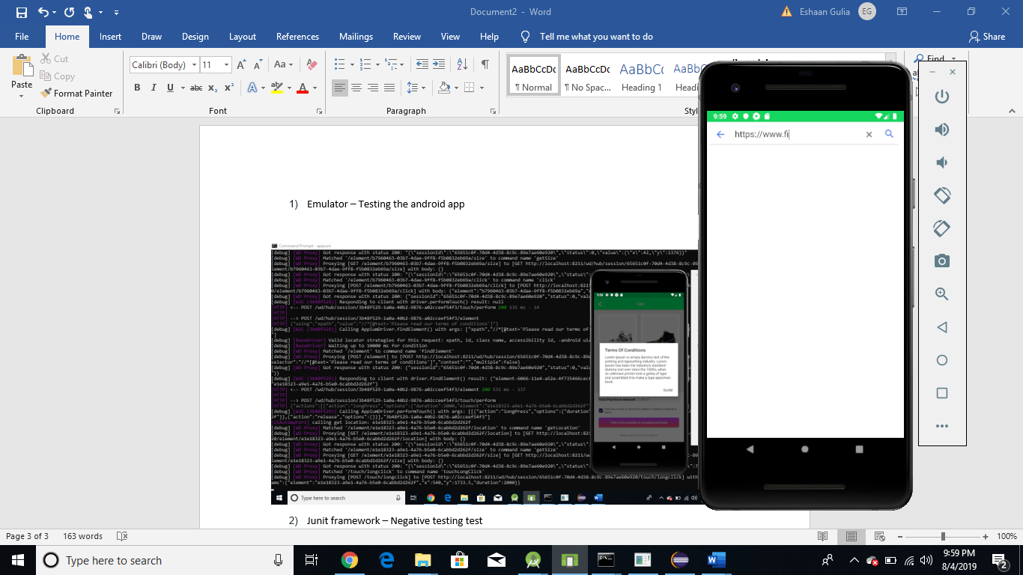

* Junit framework – showing Actual validation with the help of Junit framework.

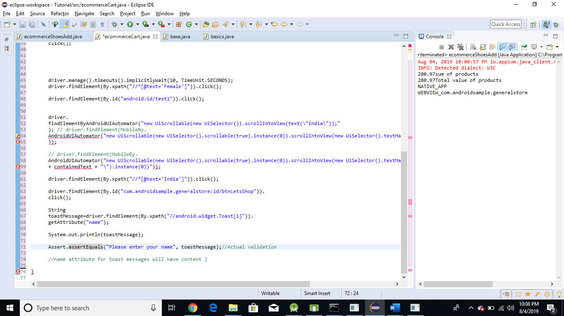

* UIAutomationViewer – Screenshots showing the UI elements.

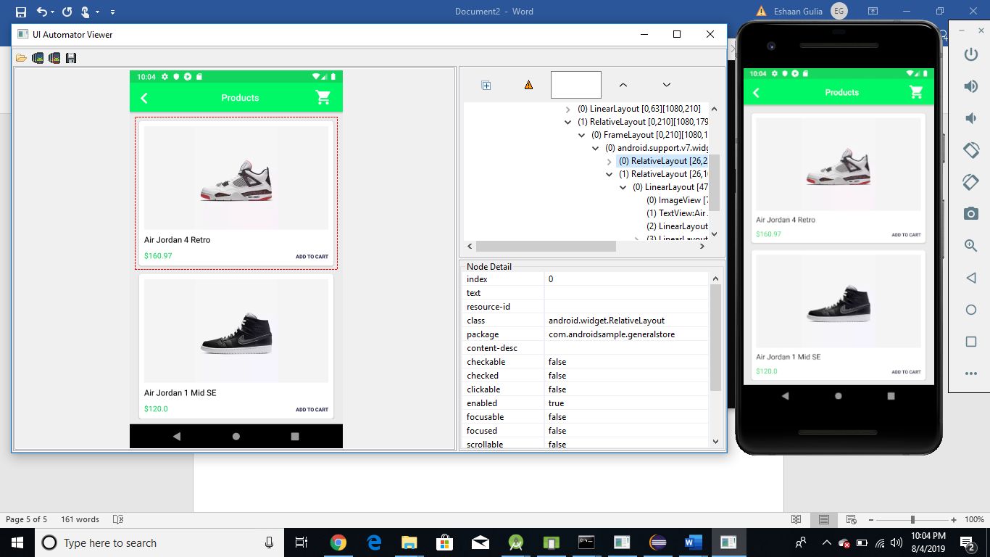

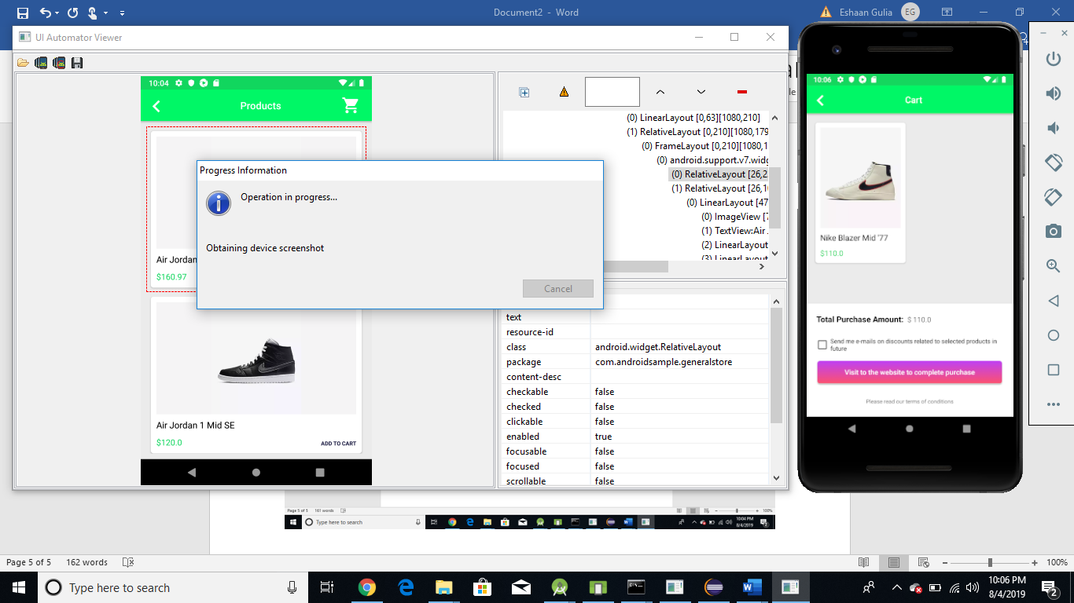

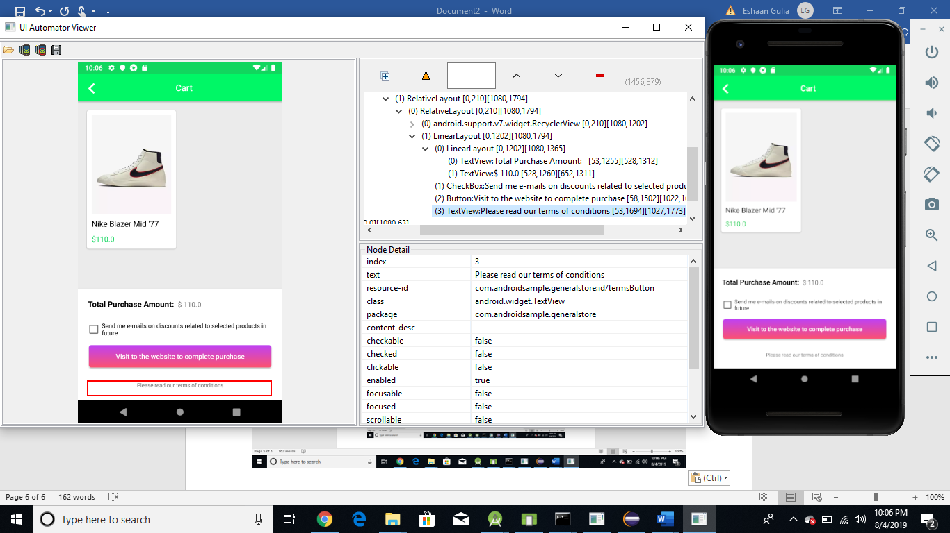

* **Automation code**
  + Base Class

**import** java.io.File;

**import** java.net.MalformedURLException;

**import** java.net.URL;

**import** org.openqa.selenium.remote.DesiredCapabilities;

**import** io.appium.java_client.android.AndroidDriver;

**import** io.appium.java_client.android.AndroidElement;

**import** io.appium.java_client.remote.MobileCapabilityType;

**public** **class** base {

**public** **static** AndroidDriver<AndroidElement> capabilities() **throws** MalformedURLException

{

AndroidDriver<AndroidElement> driver;

File appDir = **new** File("src");

File app = **new** File(appDir, "General-Store.apk");

DesiredCapabilities capabilities = **new** DesiredCapabilities();

capabilities.setCapability(MobileCapabilityType.***DEVICE_NAME***, "Pooemulator");

capabilities.setCapability(MobileCapabilityType.***APP***, app.getAbsolutePath());

driver = **new** AndroidDriver<AndroidElement>(**new** URL("http://127.0.0.1:4723/wd/hub"), capabilities);

**return** driver;

}

}

* + **eCommerceCart Shopping Cart**

**import** java.net.MalformedURLException;

**import** java.util.Set;

**import** java.util.concurrent.TimeUnit;

**import** org.openqa.selenium.By;

**import** org.openqa.selenium.Keys;

**import** org.openqa.selenium.WebElement;

**import** io.appium.java_client.TouchAction;

**import** io.appium.java_client.android.AndroidDriver;

**import** io.appium.java_client.android.AndroidElement;

**import** io.appium.java_client.android.nativekey.AndroidKey;

**import** io.appium.java_client.android.nativekey.KeyEvent;

**import** **static** io.appium.java_client.touch.TapOptions.*tapOptions*;

**import** **static** io.appium.java_client.touch.offset.ElementOption.*element*;

**import** **static** io.appium.java_client.touch.LongPressOptions.*longPressOptions*;

**import** **static** java.time.Duration.*ofSeconds*;

**import** junit.framework.Assert;

**public** **class** ecommerceShoesAdd **extends** base{

**public** **static** **void** main(String[] args) **throws** MalformedURLException, InterruptedException {

AndroidDriver<AndroidElement> driver=*capabilities*();

driver.manage().timeouts().implicitlyWait(10, TimeUnit.***SECONDS***);

driver.findElement(By.*id*("com.androidsample.generalstore:id/nameField")).sendKeys("Sonia Gulia");

driver.hideKeyboard();

driver.findElement(By.*xpath*("//*[@text='Female']")).click();

driver.findElement(By.*id*("android:id/text1")).click();

//Scrolling through the list of country's

driver.findElementByAndroidUIAutomator("new UiScrollable(new UiSelector()).scrollIntoView(text(\"India\"));");

driver.findElement(By.*xpath*("//*[@text='India']")).click();

driver.findElement(By.*id*("com.androidsample.generalstore:id/btnLetsShop")).click();

//add items to the cart

driver.findElements(By.*xpath*("//*[@text='ADD TO CART']")).get(0).click();

driver.findElements(By.*xpath*("//*[@text='ADD TO CART']")).get(0).click();

driver.findElement(By.*id*("com.androidsample.generalstore:id/appbar_btn_cart")).click();

Thread.*sleep*(4000);

**int** count=driver.findElements(By.*id*("com.androidsample.generalstore:id/productPrice")).size();

**double** sum=0;

**for**(**int** i=0;i<count;i++)

{

String amount1= driver.findElements(By.*id*("com.androidsample.generalstore:id/productPrice")).get(i).getText();

**double** amount=*getAmount*(amount1);

sum=sum+amount;//280.97+116.97

}

System.***out***.println(sum+"sum of products");

String total=driver.findElement(By.*id*("com.androidsample.generalstore:id/totalAmountLbl")).getText();

total= total.substring(1);

**double** totalValue=Double.*parseDouble*(total);

System.***out***.println(totalValue+"Total value of products");

Assert.*assertEquals*(sum, totalValue);

//Mobile Gestures

WebElement checkbox=driver.findElement(By.*className*("android.widget.CheckBox"));

TouchAction t=**new** TouchAction(driver);

t.tap(*tapOptions*().withElement(*element*(checkbox))).perform();

//Long Pause for the terms of conditions.

WebElement tc=driver.findElement(By.*xpath*("//*[@text='Please read our terms of conditions']"));

t.longPress(*longPressOptions*().withElement(*element*(tc)).withDuration(*ofSeconds*(2))).release().perform();

driver.findElement(By.*id*("android:id/button1")).click();

driver.findElement(By.*id*("com.androidsample.generalstore:id/btnProceed")).click();

Thread.*sleep*(7000);

Set<String> contexts=driver.getContextHandles();

**for**(String contextName :contexts)

{

System.***out***.println(contextName);

}

//Switching to the browser.

driver.context("WEBVIEW_com.androidsample.generalstore");

driver.findElement(By.*name*("q")).sendKeys("https://www.finastra.com/");

driver.findElement(By.*name*("q")).sendKeys(Keys.***ENTER***);

//Switching back to the App.

driver.pressKey(**new** KeyEvent(AndroidKey.***BACK***));

driver.context("NATIVE_APP");

}

**public** **static** **double** getAmount(String value)

{

value= value.substring(1);

**double** amount2value=Double.*parseDouble*(value);

**return** amount2value;

}

}

* **eCommerceCart Cart – Negative test case.**

import java.net.MalformedURLException;

import java.util.concurrent.TimeUnit;

import org.openqa.selenium.By;

import io.appium.java_client.MobileBy;

import io.appium.java_client.android.AndroidDriver;

import io.appium.java_client.android.AndroidElement;

import junit.framework.Assert;

public class ecommerceCart extends base {

public static void main(String[] args) throws MalformedURLException,

InterruptedException {

AndroidDriver<AndroidElement> driver=capabilities();

driver.manage().timeouts().implicitlyWait(10, TimeUnit.SECONDS);

driver.findElement(By.id("com.androidsample.generalstore:id/nameField")).

sendKeys("Sonia Gulia");

driver.hideKeyboard();

driver.findElement(By.xpath("//*[@text='Female']")).click();

driver.findElement(By.id("android:id/text1")).click();

driver.findElementByAndroidUIAutomator("new UiScrollable(new UiSelector()).scrollIntoView(text(\"India\"));");

driver.findElement(By.xpath("//*[@text='India']")).click();

driver.findElement(By.id("com.androidsample.generalstore:id/btnLetsShop")).click();

driver.manage().timeouts().implicitlyWait(10, TimeUnit.SECONDS);

driver.findElement(By.xpath("//*[@text='Female']")).click();

driver.findElement(By.id("android:id/text1")).click();

driver.findElementByAndroidUIAutomator("new UiScrollable(new UiSelector()).scrollIntoView(text(\"India\"));");

driver.findElement(By.xpath("//*[@text='India']")).click();

driver.findElement(By.id("com.androidsample.generalstore:id/btnLetsShop")).click();

String toastMessage=driver.findElement(By.xpath("//android.widget.Toast[1]")).getAttribute("name");

System.out.println(toastMessage);

Assert.assertEquals("Please enter your name", toastMessage);//Actual validation

}

}